Project Report on Unlocking insights into the Global Air Transportation Network with Tableau

Team Id :NM2023TMID07414

Senthil M

Rahul S

Muthu Ramalingam S

Veera Pandi G

* 1. Overview:

The air transport system generally includes airports, ATC (air traffic control) system, and airlines. The airports represent the ground part of the system's infrastructure handling the aircraft operated by different airlines transporting passengers and freight/cargo shipments.

* 1. Purpose
* Air transport allows people from different countries to cross international boundaries and travel other countries for personal, business, medical, and tourism purposes
* Global Air Transportation Network dataset is a comprehensive collection of information on airports, airlines and their routes. It contains information such as names, cities, countries, codes (IATA and ICAO) longitudes, latitudes and altitudes of airports across the world with detailed time zone and daylight saving time data
* Goods and services get to us or can be delivered sooner and often would not be obtainable at all without the role of air transport for the product or the people who provide the service.
* It allows us to have a wider sense of community because the time involved in physical connection is so much less

2.1 Emp athy Map

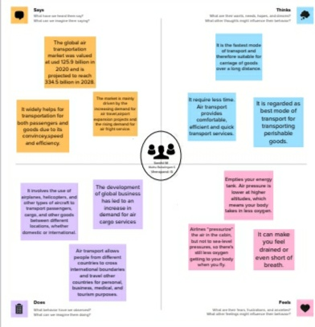

2.2 Ideation and Brainstorming Map

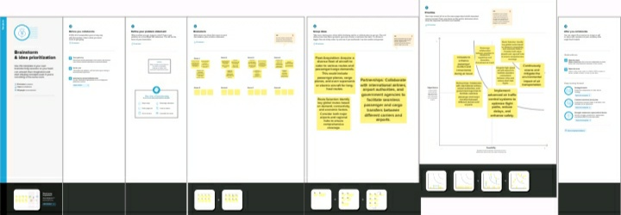

2.3 Result

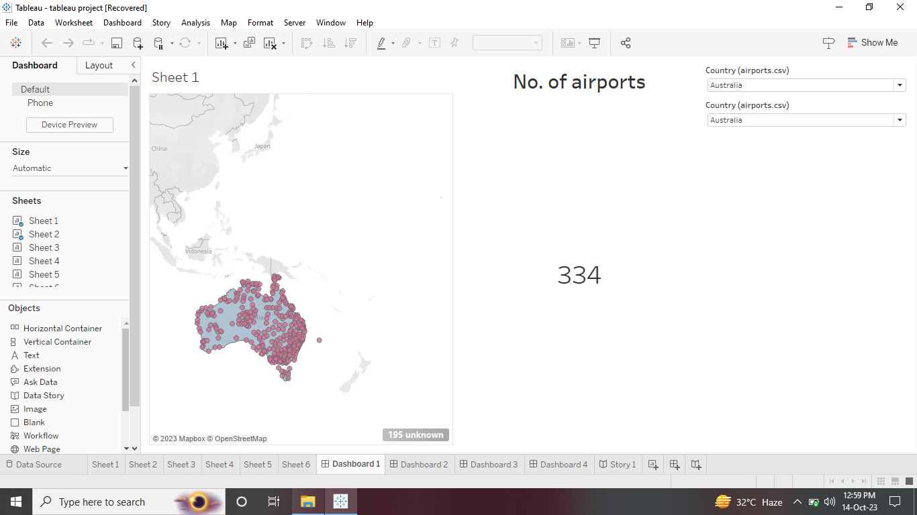

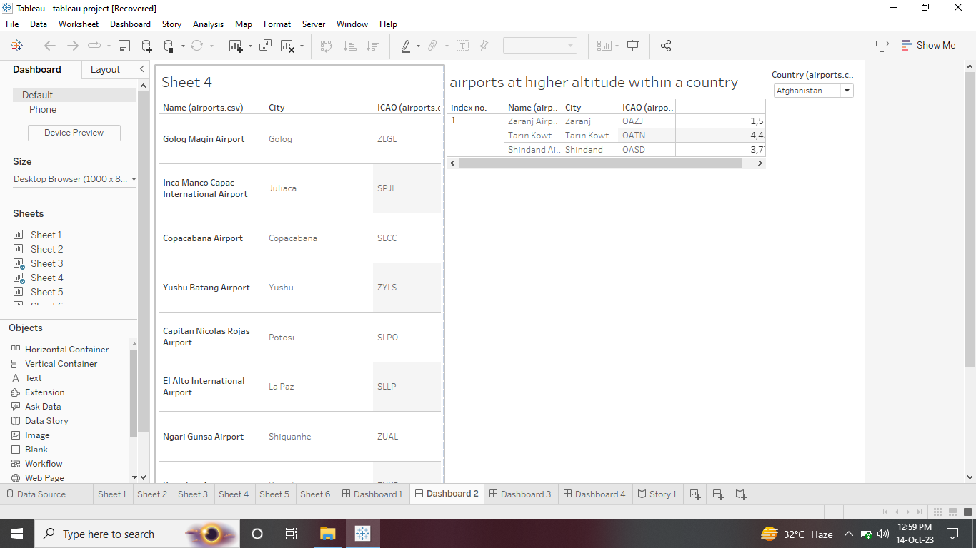

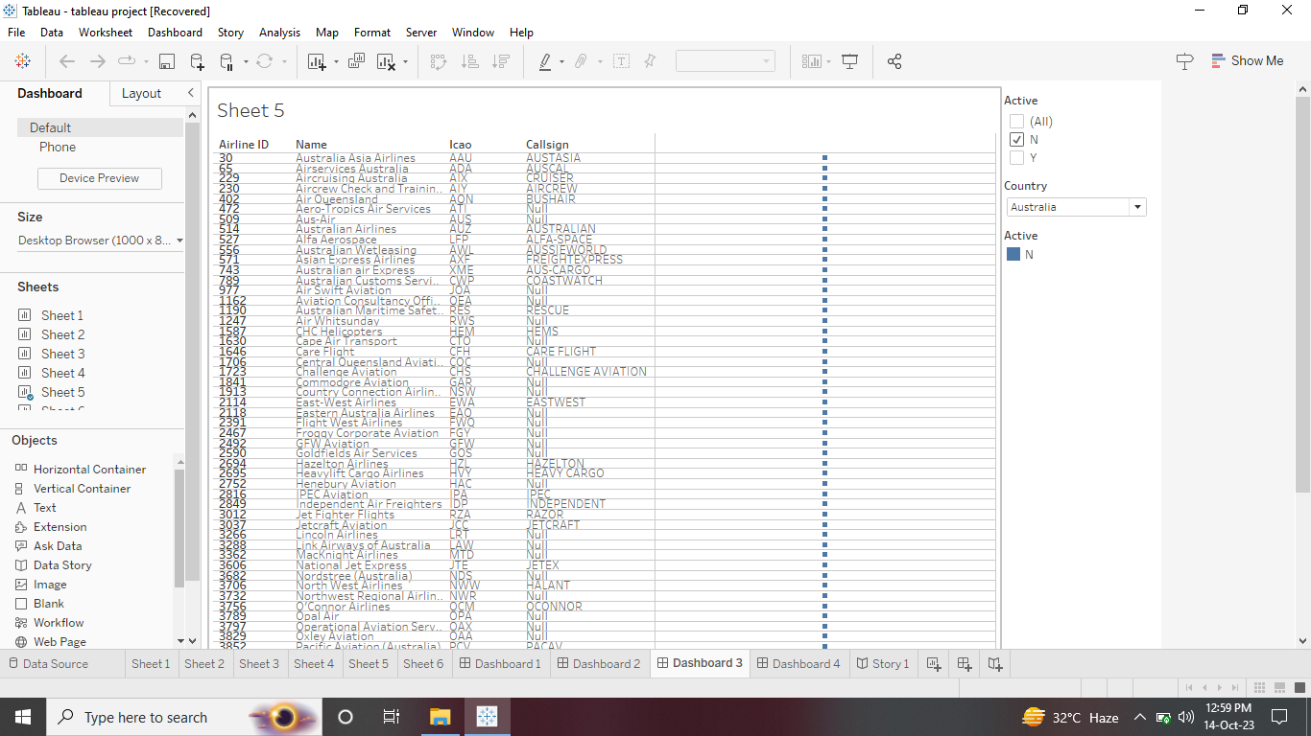

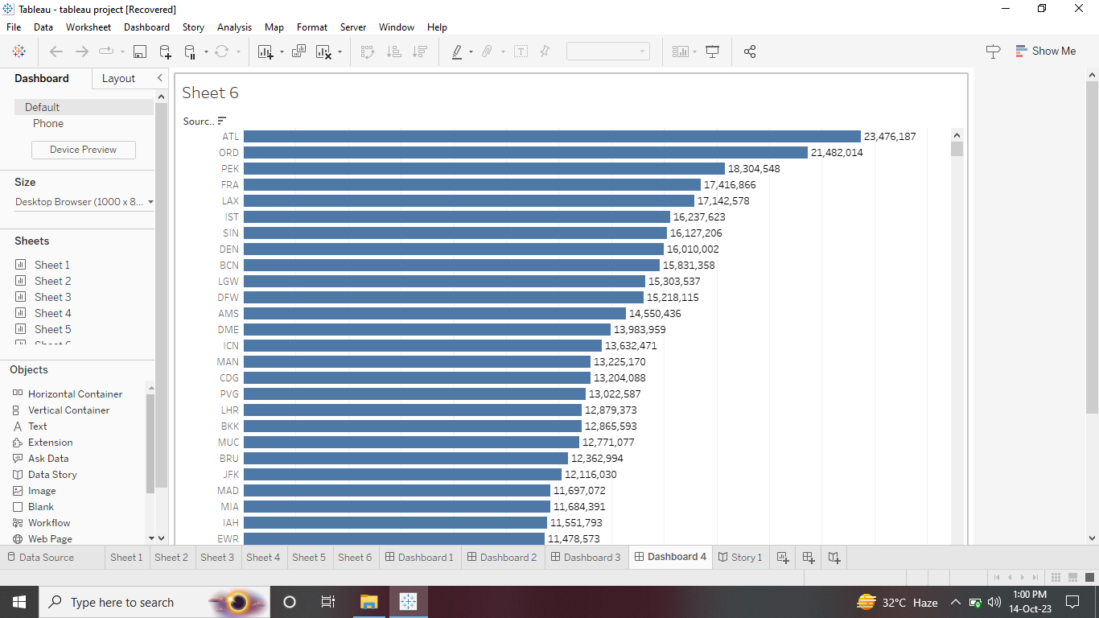

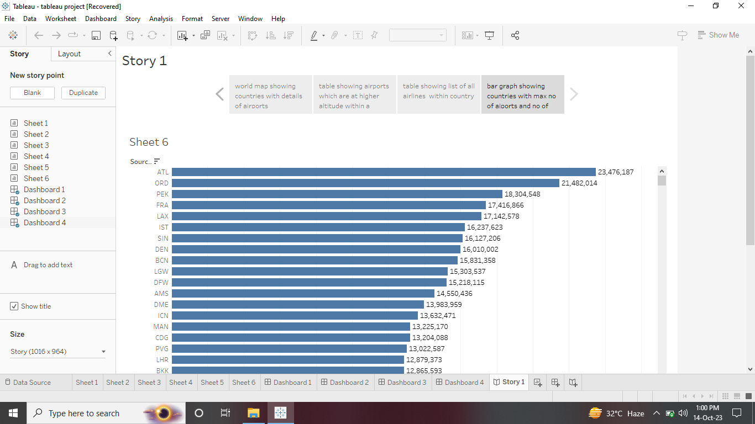

4 Advantages and Disadvantages

Advantages:

* Fast delivery times. Undoubtedly, one of the most advantageous features offered by air transport is its speedy delivery times
* The **qualities of air transport make it perfectly suited to the needs of all types of industries and companies**. Although other means of transport have traditionally been used for some types of goods, air transport has been modified and improved to become increasingly versatile and efficient
* **There is no faster transport service than air transport**. In addition, the frequency of flights makes delivery times very frequent and fast
* No other means of transport in the logistics sector can **cover** such **long distances** as air transport. This is a **great advantage for international trade**, being able to cover long distances, impossible for road or sea transport.

Disadvantages

* Storage capacity is lower than land and sea transport. This is a clear disadvantage, air transport is ideal for medium or low loads, but is not so attractive for large volumes of goods
* Air transport, due to its specific characteristics, cannot carry certain products or goods. It suffers from certain restrictions, especially in liquid products such as petroleum, oils, etc
* There is no doubt that air transport is the least economical means of transportation compared to other types of transport
* Although the advantages of air transport are very attractive and define a totally unbeatable type of service, it is also possible to define a series of disadvantages that should be analyzed to determine whether air transport is appropriate or whether it is preferable to consider other types of transport, such as **sea transport**

5 Applications

* Aviation provides the only rapid worldwide transportation network, which makes it essential for global business. It generates economic growth, creates jobs, and facilitates international trade and tourism
* It has no physical barriers as in the case of other mode of transport. Political boundaries are also immaterial although it has to observe the requirements of the International Law. The supreme advantage of air transport lies in its quickness. It is the fastest mode of transport.
* As of August 2021, India has a total of 139 operational airports, up from 123 in 2014, according to the Ministry of Civil Aviation. The Indian government has also announced plans to develop 100 new airports by 2024, according to the Ministry of Civil Aviation
* The aviation industry in India faces several challenges that impact its growth and sustainability.
* These challenges include infrastructure limitations, regulatory compliance, skilled workforce shortages, high-cost structure, security concerns, and environmental impacts.
* Air India's total losses including write-offs on old aircraft and engines are estimated at ₹14,000 crore at the end of FY23. Tata Sons had invested around ₹13,000 crore in the airline company in FY23 excluding investment committed for 470 new airplanes, according to a report published by The Economic Times.
* In conclusion, air freight is a fast, flexible, and efficient shipping method that provides businesses with numerous benefits, including speed, flexibility, efficiency, and reduced risk of damage or loss
* In conclusion, Tata's acquisition of Air India has had a positive impact on the aviation industry. It has helped to make air travel more affordable and has also helped to promote innovation and research
* The transport system today plays a very vital role in the development of India. It can be ranked among the most important sectors of the Indian economy. It is the most significant event for transporting goods and services from one place to another
* The industry has a number of domestic and international airlines, as well as a large network of airports
* The future of the aviation industry in India is likely to see continued growth and expansion, driven by factors such as a growing middle class, increased tourism, and government policies supporting the industry
* The future of transportation may involve self-driving cars, drones, maglev trains and more, all in an effort to reduce carbon emissions, increase autonomous travel and promote safety and efficiency, especially in urban spaces
* The future of transportation may involve self-driving cars, drones, maglev trains and more, all in an effort to reduce carbon emissions, increase autonomous travel and promote safety and efficiency, especially in urban spaces
* The aviation industry is a highly diverse field that offers a multitude of career opportunities, ranging from pilots and air traffic controllers to engineers and maintenance technicians
* The aviation industry is a highly diverse field that offers a multitude of career opportunities, ranging from pilots and air traffic controllers to engineers and maintenance technicians
* There are a lot more employment opportunities in the aviation sector than the standard occupations that first spring to mind, such as pilot, air traffic controller, or aircraft mechanic